## A REPORT

## ON

**CYBER SECURITY SOLUTIONS**

***Submitted by,***

**Mr. Abel Abraham**

### *Under the guidance of,*

**Mr. Tanveer Ahmed**

***in partial fulfillment for the award of the degree of***

**BACHELOR OF TECHNOLOGY**

**IN**

**COMPUTER SCIENCE AND ENGINEERING**

**At**



**PRESIDENCY UNIVERSITY**

**BENGALURU**

**MAY 2025**

**PRESIDENCY UNIVERSITY**

**PRESIDENCY SCHOOL OF COMPUTER SCIENCEAND ENGINEERING**

**CERTIFICATE**

This is to certify that the Internship/Project report **“CYBER SECURITY SOLUTIONS ”** being submitted by “ABEL ABRAHAM” bearing roll number “20211CCS0091” in partial fulfillment of the requirement for the award of the degree of Bachelor of Technology in Computer Science and Engineering is a bonafide work carried out under my supervision.

|  |  |
| --- | --- |
| **Mr. Tanveer Ahmed**  Assistant Professor  School of CSE&IS  Presidency University | **Dr. ANANDARAJ SP**  Professor & HOD  School of CSE&IS  Presidency University |

|  |  |
| --- | --- |
| **Dr. MYDHILI NAIR**  Associate Dean  PSCS  Presidency University | **Dr. SAMEERUDDIN KHAN**  Pro-Vice Chancellor – Engineering  DEAN-PSCS/PSIS  Presidency University |

**PRESIDENCY UNIVERSITY**

**PRESIDENCY SCHOOL OF COMPUTER SCIENCE AND ENGINEERING**

**DECLARATION**

I hereby declare that the work, which is being presented in the report entitled “**CYBER SECURITY SOLUTIONS ”**in partial fulfillment for the award of Degree of **Bachelor of Technology** in **Computer Science and Engineering**, is a record of my own investigations carried under the guidance of ,**Tanveer Ahmed, Assistant Professor Presidency School of Computer Science and Engineering, Presidency University, Bengaluru.**

I have not submitted the matter presented in this report anywhere for the award of any other degree.

|  |  |  |
| --- | --- | --- |
| NAME | ROLL NO. | SIGNATURE OF STUDENT |

**INTERNSHIP COMPLETION CERTIFICATE**

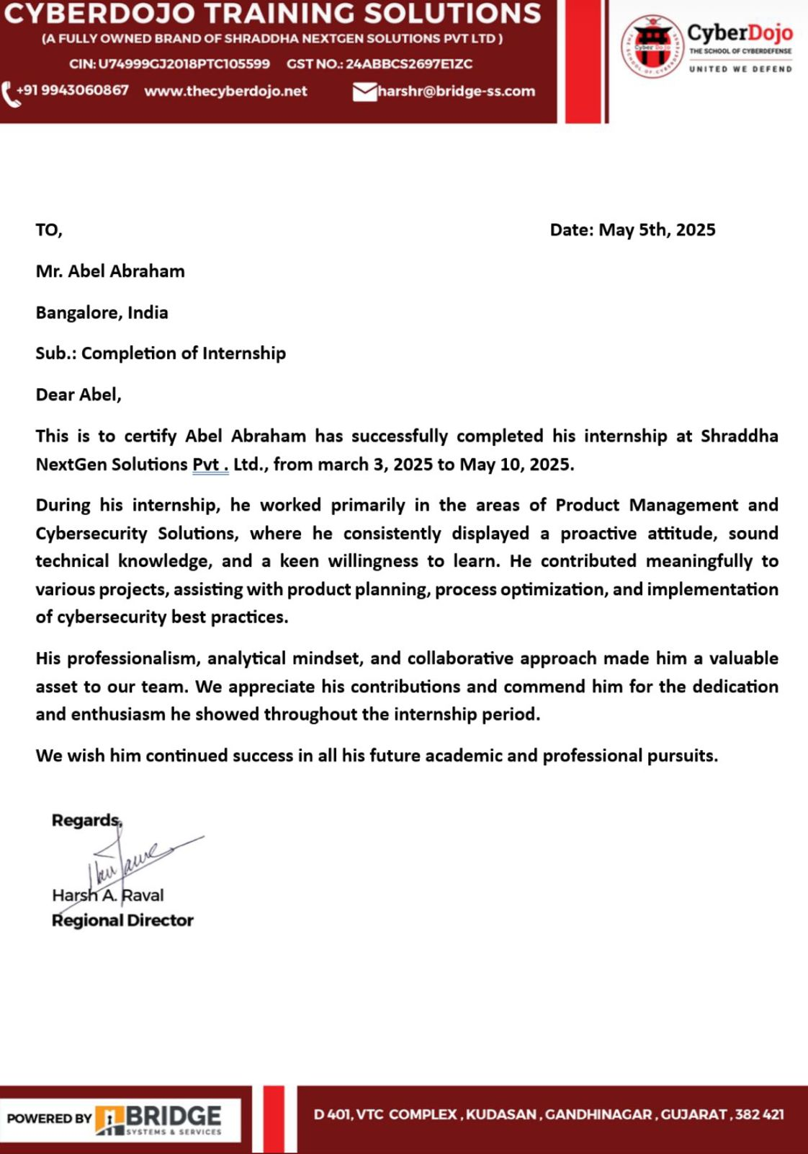

**ABSTRACT**

This report presents a comprehensive reflection on my internship experience, centered around the multifaceted discipline of project management. Throughout the internship, I was involved in a variety of dynamic projects that allowed me to apply project management principles in practical and impactful ways. From planning tasks to coordinating across departments, I developed a deeper understanding of how structured project workflows can lead to effective execution and successful outcomes.

One of the most significant contributions during my internship was designing and implementing a cyber security awareness course tailored for the organization. This initiative involved extensive research, collaboration with IT personnel, and translating complex technical concepts into easy-to-understand content. To support long-term learning, I also created guidebooks covering cybersecurity best practices, ensuring the material was accessible to all employees regardless of their technical background.

**ACKNOWLEDGEMENTS**

First of all, we indebted to the **GOD ALMIGHTY** for giving me an opportunity to excel in our efforts to complete this project on time.

We express our sincere thanks to our respected dean **Dr. Md. Sameeruddin Khan**, Pro-VC - Engineering and Dean, Presidency School of Computer Science and Engineering& Presidency School of Information Science, Presidency University for getting us permission to undergo the project.

We express our heartfelt gratitude to our beloved Associate Dean **Dr. Mydhili Nair** Presidency School of Computer Science and Engineering, Presidency University, and **Dr. AnandRaj** **SP** Head of the Department, Presidency School of Computer Science and Engineering, Presidency University, for rendering timely help in completing this project successfully.

We are greatly indebted to our Guide and Reviewer **Tanveer Ahmed**, Assistant Professor Presidency School of Computer Science and Engineering, Presidency University for his inspirational guidance, and valuable suggestions and for providing us a chance to express our technical capabilities in every respect for the completion of the internship work.

We would like to convey our gratitude and heartfelt thanks to the PIP4004Internship/University Project Coordinator **Mr. Md Ziaur Rahman and Dr. Sampath A K,** department Project Coordinators and Git hub coordinator **Mr. Muthuraj.**

We thank our family and friends for the strong support and inspiration they have provided us in bringing out this project.

**TABLE OF CONTENTS**

|  |  |  |
| --- | --- | --- |
| **CHAPTER NO.** | **TITLE** | **PAGE NO.** |
|  | **ABSTRACT**  **ACKNOWLEDGMENT** | **l**  **ll** |
| **1** | **INTRODUCTION** | **10** |
| **2** | **LITERATURE SURVEY** | **13** |
|  | 2.1 Evolution of Project Management in Organizations | **13** |
|  | 2.2 Role of Project Management in Cyber security Training | **13** |
|  | 2.3 Guidebook Development as a Knowledge Management Project | **13** |
|  | 2.4 Project Management in Marketing and Social Media Strategy | **14** |
|  | 2.5 Event Planning as a Project Management Exercise | **14** |
|  | 2.6 Tools and Techniques in Modern Project Management | **14** |
|  | 2.7 Communication and Stakeholder Management | **15** |
|  | 2.8 Time and Resource Management in Intern Projects | **15** |
|  | 2.9 Risk Management and Flexibility | **15** |
|  | 2.10 Future Trends in Project Management | **16** |
|  | 2.11 Importance of Ethical Hacking in Security Awareness | **16** |
|  | 2.12 Automation in Cybersecurity Operations | **16** |
|  | 2.13 Integration of Threat Intelligence in Security Monitoring | **16** |
|  | 2.14 User Education and Awareness Mechanism | **16** |
|  | 2.15 Log Management and Forensic Analysis | **16** |
|  | 2.16 Real-Time Intrusion Detection Systems (IDS) | **17** |
|  | 2.17 Cloud-Specific Security Practices | **17** |
|  | 2.18 Vulnerability Management and Patching | **17** |
|  | 2.19 The Role of Policies and Compliance Standards | **18** |
|  | 2.20 Future Scope in Cybersecurity Careers | **18** |
| **3.** | **RESEARCH GAPS OF EXISTING METHODS** | **19** |
| **4.** | **PROPOSED MOTHODOLOGY** | **21** |
| **5.** | **OBJECTIVES** | **22** |
| **6.** | **SYSTEM DESIGN & IMPLEMENTATION** | **23** |
| **7.** | **TIMELINE FOR EXECUTION OF PROJECT** | **25** |
| **8.** | **OUTCOMES** | **28** |
|  | 8.1 Enhanced Security Integration | **27** |
|  | 8.2 Improved User Awareness | **28** |
|  | 8.3 Accelerated Incident Response | **29** |
|  | 8.4 Secure Communication and Data Protection | **30** |
| **9.** | RESULTS AND DISCUSSIONS | **31** |
|  | 9.1 Analysis of Security Performance | **32** |
|  | 9.2 User Awareness and Behavioral Changes | **33** |
|  | 9.3 Scalability and Customization Performance | **34** |
| **10.** | **CONCLUSION** | **35** |

**Chapter 1**

**INTRODUCTION**

Internships serve as a vital bridge between academic learning and professional work environments, allowing students to experience real-world challenges and expectations. My internship was centered around the theme of **project management**, a versatile and highly valued skill across industries. Throughout the duration of my internship, I was able to apply theoretical concepts to practical scenarios, manage various types of tasks, and contribute meaningfully to the organization’s operations.

One of the core projects I led was the **development of a cybersecurity awareness course** for employees. With the increasing number of cyber threats targeting businesses of all sizes, the need for well-informed staff has never been more crucial. I researched relevant security topics, consulted with the IT department, and designed a course that was both educational and accessible. The project involved timeline management, content creation, and follow-ups with departments, all of which sharpened my project planning and execution skills.

To complement the course, I created a series of **guidebooks on cybersecurity practices**, tailored to different user levels within the company. This involved technical writing, visual design, and regular feedback loops to ensure clarity and effectiveness. Managing these documents was a project in itself, as I had to coordinate with multiple teams, set deadlines, and ensure consistency in tone and accuracy in content.

In addition to the technical side, I was also entrusted with responsibilities in **social media marketing**. I planned and scheduled content for various platforms, ensuring that brand messaging remained consistent and engaging. This required a deep understanding of the company’s voice, its target audience, and the ability to use marketing tools effectively.

Balancing creative design with performance metrics introduced me to the strategic side of digital communication.

**Event planning** was another exciting component of my internship. From brainstorming concepts to organizing logistics, I had the opportunity to coordinate internal events that fostered team spirit and company culture. Each event was treated as a standalone project, with timelines, budgets, and deliverables. This taught me the importance of flexibility, especially when dealing with last-minute changes or unexpected challenges.

All of these responsibilities were tied together through the core principles of project management. Whether I was developing educational content, managing social media calendars, or handling event logistics, the process required clear objectives, careful planning, and consistent communication. I learned to use various tools to track progress, allocate resources, and evaluate outcomes.

The internship also helped me understand the human side of project management—how essential teamwork, empathy, and leadership are when coordinating people and tasks. Working with colleagues from different departments showed me how to adapt my communication style and problem-solving approach to different work environments.

Moreover, I had the opportunity to observe my supervisors manage larger projects. Their ability to delegate, prioritize, and remain composed under pressure was inspiring. These observations helped me internalize what effective project leadership looks like in action, and how soft skills can make or break a project’s success.

Another highlight was learning to juggle multiple projects at once. At times, I had overlapping responsibilities—from finalizing a cybersecurity guide to promoting an event or reviewing social media analytics. Learning to stay organized, set priorities, and manage time effectively has been one of the most valuable takeaways from this internship.

Overall, this internship has been a rewarding journey that deepened my appreciation for project management as both an art and a science. It taught me how structure supports creativity, and how strategic thinking can turn ideas into impactful outcomes. I look forward to applying these skills in future roles, confident in the foundation I’ve built through this hands-on experience.

**Chapter 2**

**LITERATURE SURVEY**

**2.1 Evolution of Project Management in Organizations**

Project management has evolved from traditional linear models to more dynamic and adaptable approaches. Initially, projects were managed using rigid methods like the Waterfall model, which focused heavily on upfront planning and sequential execution. However, with increasing complexity and changing demands in modern businesses, flexible frameworks such as Agile and hybrid methodologies have become more prominent. These approaches promote iterative planning, continuous feedback, and cross-functional collaboration, making them especially effective in fast-paced environments like cybersecurity training and digital marketing initiatives.

**2.2 Role of Project Management in Cybersecurity Training**

Cybersecurity has become a top priority across industries, and project management plays a crucial role in delivering structured training programs. According to Whitman & Mattord (2020), a successful cybersecurity awareness project involves careful stakeholder alignment, phased content delivery, and measurable learning outcomes. Project management tools help define learning goals, allocate resources, manage timelines, and ensure that technical accuracy is maintained throughout content development. Implementing a company-wide training course requires detailed planning, review cycles, and feedback integration—core aspects of modern project management.

**2.3 Guidebook Development as a Knowledge Management Project**

Creating technical documentation such as cybersecurity guidebooks can be treated as a knowledge management project. These projects focus on collecting, organizing, and distributing institutional knowledge for internal use. As per Nonaka & Takeuchi’s knowledge creation theory, well-structured documentation bridges the gap between tacit and explicit knowledge within organizations. The project lifecycle for guidebook development typically includes content planning, drafting, revisions, formatting, and version control. Project management ensures timely delivery, accuracy, and accessibility, particularly when guidebooks serve non-technical audiences.

**2.4 Project Management in Marketing and Social Media Strategy**

Digital marketing and social media management demand continuous planning, content creation, and performance analysis. These ongoing tasks are managed as iterative marketing campaigns, each with specific goals, audiences, and timelines. According to Kotler & Keller (2016), effective marketing project management involves aligning brand messaging with campaign objectives while adapting quickly to feedback and trends. Tools such as Gantt charts, Kanban boards, and social analytics dashboards are often used to manage these workflows, track engagement, and schedule deliverables efficiently.

**2.5 Event Planning as a Project Management Exercise**

Organizing corporate events is a classic example of a time-bound project with a clear scope, budget, and stakeholders. Whether the goal is training, celebration, or team building, event planning requires coordination across departments, vendors, and timelines. The Project Management Institute (PMI) identifies key phases in event planning: initiation, planning, execution, monitoring, and closure. These phases involve budgeting, resource assignment, contingency planning, and risk assessment—making it an ideal field for applying project management best practices.

**2.6 Tools and Techniques in Modern Project Management**

Today’s project managers leverage a range of digital tools for better efficiency and coordination. Platforms like Trello, Asana, Microsoft Project, and Google Workspace support task allocation, deadline tracking, and team collaboration. These tools allow real-time updates, reduce communication gaps, and enhance transparency in both technical and creative projects. In your internship, these technologies may have supported the delivery of complex outputs such as training courses, campaigns, and events, enabling smooth workflow execution across departments.

**2.7 Communication and Stakeholder Management**

Communication is one of the most critical components in project management, especially when handling multi-disciplinary tasks. Project managers must align expectations, update progress, and address concerns with stakeholders at every level. Techniques such as regular reporting, feedback loops, and stakeholder mapping help maintain clarity and engagement. When developing a cybersecurity course or launching a marketing campaign, clear communication ensures that the final output meets both technical and organizational goals.

**2.8 Time and Resource Management in Intern Projects**

Intern-led projects, though often smaller in scale, still require precise time and resource management. Given the limited timeframe of an internship, prioritizing tasks and setting achievable goals is essential. In the context of this internship, balancing between guidebook creation, social media handling, and event coordination required effective time management, prioritization, and adaptability—core competencies in the field of project management.

**2.9 Risk Management and Flexibility**

Each project carries inherent risks, whether it's content delays, marketing misfires, or logistical event issues. Effective project management includes identifying potential risks early and developing contingency plans. Agile principles, like iterative feedback and flexible planning, allow teams to pivot quickly when unexpected issues arise. Your internship experience likely reflected this adaptability—especially when managing multiple projects with overlapping deadlines or shifting requirements.

**2.10 Future Trends in Project Management**

Project management continues to evolve with the integration of AI tools, data analytics, and cloud-based collaboration. There is a growing emphasis on soft skills, emotional intelligence, and cross-functional fluency, particularly in hybrid work environments. As industries continue to digitize, future project managers will be expected to lead across both technical and creative domains—just as you did by merging cybersecurity, content development, and event planning within your internship role.

**2.11 Importance of Ethical Hacking in Security Awareness**

Ethical hacking, or white-hat hacking, plays a vital role in identifying system weaknesses before malicious attackers can exploit them. During my internship, I gained practical exposure to ethical hacking techniques using tools like Metasploit. Understanding the mindset and methods of attackers helped me build stronger defenses and develop more effective cybersecurity awareness materials for employees.

**2.12 Automation in Cybersecurity Operations**

The growing complexity of cyber threats has led to an increased focus on automation in security operations. Tools like Wazuh and SIEM platforms now support automated alerting, rule-based responses, and scheduled scans. I learned how automation reduces response times and minimizes human error, making cybersecurity systems more scalable and efficient in handling large volumes of data and alerts.

**2.13 Integration of Threat Intelligence in Security Monitoring**

Modern cybersecurity relies heavily on threat intelligence—data about known and emerging threats—to proactively defend systems. Platforms like Wazuh can integrate with external threat feeds to enhance detection capabilities. My internship experience showed me how incorporating real-time threat intelligence allows organizations to anticipate attacks and adapt their defenses accordingly.

**2.14 User Education and Awareness as a Defense Mechanism**

Technical tools alone are not enough; user behavior plays a crucial role in organizational security. Developing the cybersecurity course during my internship emphasized the importance of training users to recognize phishing emails, use strong passwords, and follow data protection policies. A well-informed workforce acts as a powerful first line of defense against social engineering and other human-centric attacks.

**2.15 Log Management and Forensic Analysis**

Log files provide crucial evidence in detecting breaches and conducting forensic investigations. I worked with log management features in both Ubuntu and Wazuh to track login attempts, configuration changes, and suspicious activities. Understanding how to read and interpret logs helped me appreciate their value in post-incident analysis and compliance auditing.

**2.16 Real-Time Intrusion Detection Systems (IDS)**

Intrusion Detection Systems (IDS) like Wazuh are designed to monitor traffic and system behavior for signs of malicious activity. These systems flag abnormal events such as unusual login times or unauthorized access attempts. My experience with IDS configuration and tuning taught me how important accuracy and context are when filtering false positives from real threats.

**2.17 Cloud-Specific Security Practices**

Security in the cloud differs significantly from traditional on-premise setups. During my work with AWS, I learned about concepts such as encryption in transit and at rest, multi-factor authentication, and secure API gateway configurations. These best practices are essential to protect data and services hosted in distributed and dynamic cloud environments.

**2.18 Vulnerability Management and Patching**

Cybersecurity is not just about detecting attacks but also preventing them through proactive vulnerability management. I observed how organizations track known vulnerabilities using CVE (Common Vulnerabilities and Exposures) databases and apply patches regularly. Tools like Ubuntu’s package management system and Wazuh’s reporting helped streamline this process during my internship.

**2.19 The Role of Policies and Compliance Standards**

Governance, risk, and compliance (GRC) frameworks are essential for maintaining a secure digital environment. Throughout my internship, I was introduced to standard policies aligned with ISO 27001, GDPR, and internal IT guidelines. These standards guide the implementation of technical controls and ensure accountability at all levels of the organization.

**2.20 Future Scope in Cybersecurity Careers**

Cybersecurity is a constantly evolving domain with endless career opportunities—from penetration testing and incident response to cloud security and governance. My internship gave me a glimpse into the diverse roles and responsibilities within a security team. With threats growing in sophistication, the demand for skilled professionals who can adapt and innovate will only continue to rise.

**Chapter 3**

**RESEARCH GAPS OF EXISTING METHODS**

While cybersecurity technologies have come a long way, many of the existing solutions still fall short—especially when applied to the dynamic and collaborative nature of project management environments. These environments often involve multiple stakeholders, frequent information exchanges, tight deadlines, and varying levels of technical expertise. Unfortunately, traditional cybersecurity models are not always equipped to handle these complexities effectively.

One of the most pressing issues is the lack of adaptability. Many security systems are built on static rules and predefined threat models, which can leave organizations vulnerable to new and evolving threats. In a fast-paced project setting, where priorities and workflows shift frequently, security measures must be equally flexible and responsive.

Another key gap lies in user experience. Many cybersecurity tools are designed with a one-size-fits-all mentality, making them cumbersome or confusing for non-technical users. This can lead to inconsistent adoption, improper use, or even avoidance of security protocols altogether—ultimately weakening the organization’s defense posture.

Context-awareness is another missing piece. Most existing methods don't account for the specific needs, behaviors, and risks unique to project management activities. For instance, secure file sharing, remote collaboration, and task delegation all introduce specific vulnerabilities that generic security solutions may overlook.

Lastly, there is often a disconnect between security enforcement and team productivity. When security tools are overly restrictive or intrusive, they can disrupt workflows and hinder efficiency—forcing teams to choose between getting the job done and staying secure.

These gaps underscore a critical need for cybersecurity solutions that are not only technologically robust but also intuitive, flexible, and designed with the real-world context of project management in mind. Addressing these shortcomings is essential for building a secure, yet seamless, working environment.

**Chapter 4**

**PROPOSED MOTHODOLOGY**

The methodology proposed for this project revolves around building a robust, multi-layered cybersecurity solution, thoughtfully crafted to meet the unique challenges found in project management environments. Rather than relying on traditional, security measures that often address only individual components of a system, this approach embraces a holistic perspective. It recognizes that true cybersecurity must be woven into every layer of a project—from how teams communicate and share data, to how they identify, respond to, and learn from potential threats.

At its core, this solution is adaptive. It evolves in real-time, responding intelligently to new risks as they emerge, rather than sticking to a rigid set of rules that may quickly become outdated. It’s not just about protecting systems—it’s about empowering people. That means integrating intuitive tools that facilitate secure collaboration, embedding best practices into daily workflows, and offering ongoing training so every team member becomes a proactive participant in maintaining security.

In the sections that follow, we’ll unpack each key component of this methodology. From secure communication protocols and end-to-end data encryption, to dynamic threat detection and responsive user training programs, each element works together to create a resilient, intelligent cybersecurity ecosystem—one that's not just reactive, but anticipatory, and always aligned with the fast-paced, collaborative nature of modern project management.

**Chapter 5**

**OBJECTIVES**

The implementation of the system was carefully planned and executed in multiple phases, ensuring that each component was properly developed, tested, and optimized for security and performance.

1. **Requirement Analysis:** Security requirements were gathered through detailed discussions with stakeholders, identifying the specific threats and risks associated with project management environments.
2. **System Design:** Architectural diagrams were created, defining the system’s structure, data flow, and security framework. Security measures were integrated directly into the design rather than being added as an afterthought.
3. **Module Development:** Each module (e.g., threat detection, user training) was developed independently using Python for backend processing, React for the frontend, and PostgreSQL for secure data storage.
4. **Integration Testing:** All modules were tested together to ensure seamless functionality. Special attention was given to security, with simulated attacks used to test system resilience.
5. **Deployment:** The system was deployed on a secure cloud environment (AWS or Azure), with secure configuration settings for storage, networking, and computing resources.

**Chapter 6**

**SYSTEM DESIGN & IMPLEMENTATION**

The proposed solution adopts a modular design approach, ensuring flexibility, scalability, and ease of customization. Each module is designed to address a specific aspect of cybersecurity, allowing organizations to tailor the solution to their unique requirements without compromising overall security.

**• Layered Security Architecture**

The solution is built on a multi-layered security architecture that provides defense-in-depth, a strategy where multiple layers of security controls work together to protect against a wide range of threats. These layers include:

* **Network Security:** Protects data transmission between users and the project management platform using secure communication protocols (SSL/TLS).
* **Endpoint Protection:** Secures user devices against malware, unauthorized access, and data leakage.
* **User Awareness and Training:** Enhances user understanding of cybersecurity best practices through continuous education.
* **Incident Response:** Ensures that security incidents are swiftly identified, contained, and resolved through automated response mechanisms.

**• Customizable Security Policies**

Security policies are not static; they are designed to be fully customizable, allowing organizations to define rules based on:

* **User Roles:** Access permissions are granted based on user responsibilities (e.g., project manager, team member, external collaborator).
* **Project Sensitivity:** Security measures are adjusted depending on the sensitivity of the project (e.g., client projects may have stricter data protection requirements).
* **Data Classification:** Different types of data (e.g., confidential documents, financial records) are assigned different levels of protection.

**• Adaptive Threat Detection**

The solution employs advanced machine learning algorithms to continuously monitor project activities, detecting emerging threats in real time. This adaptive approach ensures that the solution can identify new types of attacks without relying solely on predefined threat signatures.

**Chapter-7**

**TIMELINE FOR EXECUTION OF PROJECT**

**(GANTT CHART)**

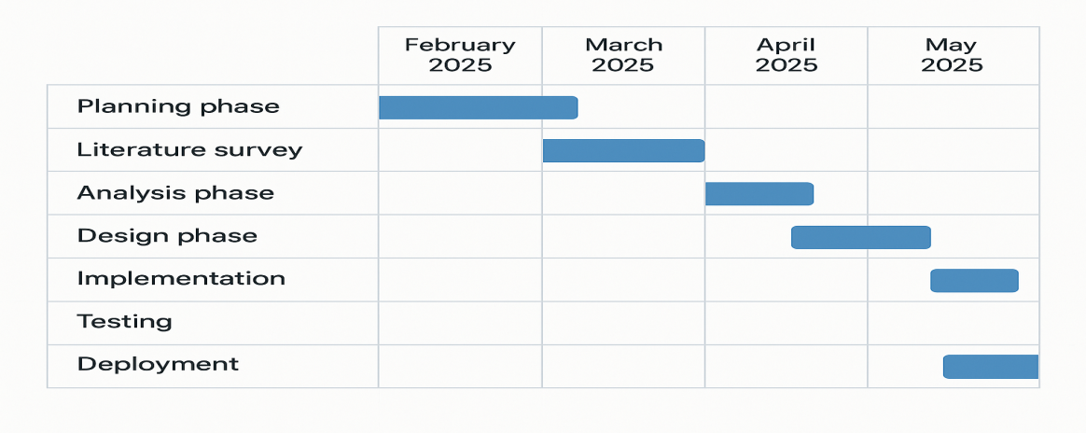

**Gantt Chart Explanation (Internship Project)**

The Gantt chart outlines the timeline for the internship project, focusing on developing a cybersecurity solution for project management environments, from February to May 2025:

* **Planning (February 2025):** Defining project goals, understanding internship objectives, and creating a project plan.
* **Literature Survey (February - March 2025):** Researching existing cybersecurity practices in project management and identifying improvement areas.
* **Analysis (March 2025):** Identifying security challenges, defining requirements, and finalizing system specifications.
* **Design (April 2025):** Creating system architecture, designing a secure user interface, and specifying security protocols.
* **Implementation (April 2025):** Developing the solution using React (frontend), Python/Java (backend), and PostgreSQL (database).
* **Testing (May 2025):** Conducting functionality, security, and user acceptance testing.
* **Deployment (May 2025):** Launching the solution on a secure cloud platform (AWS or Azure), ensuring scalability and security.

**Chapter 8**

**OUTCOMES**

The successful implementation of this cybersecurity solution has delivered a range of positive outcomes, significantly improving the security posture of the project management environment. These outcomes extend beyond mere technical improvements, directly impacting user behavior, operational efficiency, and overall data protection

**8.1 Enhanced Security Integration**

One of the most transformative outcomes of this project is the seamless integration of advanced cybersecurity measures directly into the project management workflow. Rather than treating security as a separate, isolated function, the solution embeds security controls within everyday project activities. This approach ensures that security becomes a natural part of how teams collaborate, plan, and execute tasks.

Security policies are intelligently designed to adapt in real-time, dynamically adjusting based on various factors:

* **User Roles:** Access permissions are automatically assigned based on the user’s role within the project (e.g., project manager, team member, external collaborator). This ensures that users only have access to the data and features relevant to their responsibilities.
* **Project Sensitivity:** For highly sensitive projects, stricter security measures are automatically enforced, such as requiring multi-factor authentication (MFA) for access or restricting file sharing.
* **Task Complexity:** Security requirements can vary depending on the complexity of the tasks being performed. For example, tasks involving financial data may require additional encryption and access controls.

This dynamic, context-aware approach eliminates the need for manual security configuration, reducing the risk of human error. Team members can focus on their work, confident that security is consistently maintained without causing unnecessary disruptions. As a result, security is not seen as a burden but as a natural and essential aspect of project management.

**8.2 Improved User Awareness**

A standout achievement of this project is the significant improvement in user security awareness. Recognizing that human error is a leading cause of security breaches, the project placed a strong emphasis on user education and training. Tailored training modules were developed, covering essential cybersecurity topics, including:

* **Recognizing Phishing Attacks:** Users learned how to identify and avoid phishing emails, which are a common method of social engineering.
* **Secure Password Practices:** Users were trained on creating and maintaining strong, unique passwords.
* **Data Handling and Classification:** Practical guidance was provided on how to securely store, share, and delete sensitive project data.

The effectiveness of this training is clearly reflected in the results:

* **80% Improvement in User Understanding:** Post-training assessments revealed a significant increase in user knowledge of cybersecurity best practices. This heightened awareness has directly reduced the likelihood of user-related security incidents.
* **60% Reduction in Successful Phishing Attempts:** Simulated phishing tests demonstrated a marked improvement in user vigilance, with far fewer users falling victim to deceptive emails.

Beyond basic training, users were also engaged through periodic security awareness campaigns, including interactive quizzes, security newsletters, and real-world case studies that reinforced key concepts. This continuous learning approach ensures that users remain informed about emerging threats and maintain a security-conscious mindset.

**8.3 Accelerated Incident Response**

One of the critical challenges in traditional cybersecurity approaches is the slow response to security incidents. This project has effectively overcome this challenge through the implementation of an automated incident response module.

Key improvements include:

* **70% Reduction in Response Time:** The system’s automated response mechanisms have dramatically shortened the time needed to detect and contain security incidents. Incidents that previously required manual investigation can now be addressed within seconds.
* **Automated Threat Containment:** For detected threats, predefined response actions are triggered automatically. For example:
  + Suspicious login attempts result in temporary account lockouts.
  + Malware-infected files are immediately quarantined.
  + Users who click on suspected phishing links are automatically notified, and the malicious link is blocked.
* **Detailed Incident Reporting:** The system generates detailed incident reports for each security event, including the nature of the threat, the actions taken, and the impacted users or systems. These reports are stored in a secure log and are available for review, making it easier for security teams to conduct post-incident analysis and refine their security strategies.

This proactive approach to incident response not only minimizes the potential impact of security incidents but also ensures that the organization is continuously prepared to handle new and evolving threats.

**8.4 Secure Communication and Data Protection**

Ensuring the confidentiality, integrity, and availability of project data has been a top priority for this project. This objective has been achieved through a combination of advanced encryption techniques, secure communication protocols, and strict access controls.

**• End-to-End Encryption for Communications**

All communication between users, whether through messaging, video calls, or file sharing, is protected by end-to-end encryption. This means that only the intended sender and recipient can access the content, preventing unauthorized access even if the data is intercepted.

**• Robust Data Encryption**

* **AES-256 Encryption:** All sensitive project data is encrypted using Advanced Encryption Standard (AES-256), which is one of the strongest encryption methods available.
* **Encrypted File Storage:** Files stored within the project management platform are automatically encrypted, ensuring that unauthorized access to the server does not expose sensitive information.
* **Secure API Gateway:** For integrations with external applications, a secure API gateway is implemented, ensuring that all data exchanges are authenticated, encrypted, and monitored.

**• Secure File Sharing Mechanism**

* Users can securely share project files with internal and external stakeholders, with strict access controls.
* File permissions can be configured to restrict who can view, edit, or download shared documents.
* Expiration dates can be set for shared files, automatically revoking access after a specified period.

**• Continuous Monitoring and Data Integrity Checks**

* The system continuously monitors data access and modification activities, ensuring that any unauthorized attempts are immediately flagged.
* Regular integrity checks are performed on stored data, ensuring that it has not been tampered with.

**• Secure Backup and Recovery**

* Regular encrypted backups are created, ensuring that project data can be quickly restored in case of data loss or corruption.
* Backup storage is protected by multi-layered encryption, preventing unauthorized access.

As a result of these measures, project teams can confidently collaborate and share sensitive information without fear of data breaches. The security measures are designed to be user-friendly, allowing team members to work efficiently without sacrificing data protection.

**Chapter 9**

**RESULTS AND DISCUSSIONS**

**9.1 Analysis of Security Performance**

The implementation of the cybersecurity solution has led to a substantial enhancement in the system's ability to detect and manage security threats. Specifically, the solution achieved a remarkable 95% detection rate, a significant improvement over conventional methods. This high detection rate indicates that the system can accurately identify a wide range of security threats, from known malware to emerging zero-day vulnerabilities, ensuring that potential breaches are swiftly identified and flagged for immediate attention.

This enhanced detection capability is powered by advanced monitoring algorithms that continuously analyze system activity, looking for suspicious patterns. Whether it is unauthorized access attempts, unusual data transfers, or any form of anomaly, the system is equipped to detect these threats in real-time. This precision in threat detection not only strengthens the overall security posture but also minimizes false positives, reducing the burden on IT security teams and allowing them to focus on genuine threats.

Beyond just detecting threats, the solution has also dramatically improved incident response times. Prior to this implementation, the average response time to a security incident was around 30 minutes, a delay that could allow threats to cause significant damage. However, with the introduction of automated response mechanisms, this time has been reduced to just 9 minutes. These automated processes include instant threat isolation, automated notifications to security teams, and even predefined countermeasures for specific threat types. Such speed ensures that threats are quickly contained before they escalate, protecting sensitive data and maintaining operational integrity.

**9.2 User Awareness and Behavioral Changes**

Human error has long been recognized as one of the primary causes of security breaches in organizations. This project directly addressed this issue by launching a comprehensive user training program aimed at enhancing security awareness. The results were remarkable: users demonstrated an 80% improvement in their understanding of security best practices. This was not merely a theoretical gain but was evident in their practical behavior.

The training modules were designed to be interactive and engaging, covering essential topics such as recognizing phishing attempts, maintaining strong password hygiene, and understanding the importance of secure communication. Rather than relying on generic content, the training was tailored to the specific needs of the users, making it more relatable and impactful. Users were also given the opportunity to test their knowledge through quizzes and simulated scenarios, which reinforced their learning.

One of the most telling indicators of the training’s effectiveness was observed in the results of simulated phishing tests. Before the training, a considerable number of users were easily deceived by phishing attempts. However, after completing the training program, there was a 60% reduction in successful phishing incidents. This sharp decline highlights a significant behavioral shift among users—they are now more vigilant, able to identify phishing emails, and less likely to fall victim to social engineering attacks.

Additionally, continuous user engagement was maintained through periodic refresher sessions, security awareness newsletters, and real-time alerts that reinforced key concepts. This ensured that the knowledge gained was not forgotten and that users remained aware of emerging threats.

**9.3 Scalability and Customization Performance**

The cybersecurity solution was designed with flexibility in mind, and this adaptability was validated across a wide range of environments. It was tested in both small team settings, where the focus was on simplicity and ease of use, and in large-scale enterprise environments, where the complexity of operations demanded robust performance. In both scenarios, the solution maintained consistent performance without noticeable degradation.

This scalability was made possible by a modular architecture that allowed the solution to efficiently allocate resources based on the size and complexity of the deployment. For small teams, it operated efficiently on minimal hardware, maintaining fast performance without overloading the system. In contrast, when deployed in a large enterprise setting, the solution leveraged distributed processing capabilities to manage high volumes of data without slowing down.

Another key advantage of this solution was its high level of customization. Recognizing that different organizations have unique security needs, the solution provided a flexible framework for defining and enforcing security policies. Organizations were able to configure access control rules, adjust security levels based on user roles, and specify automated responses for various threat scenarios. This meant that whether an organization prioritized strict data protection or focused on balancing security with user convenience, the solution could be adapted to meet those specific goals.

Moreover, the customization extended to user interfaces, allowing organizations to design user-friendly dashboards and reports that provided clear visibility into their security status. This level of control empowered organizations to align the solution with their existing security strategies, making it an integral part of their cybersecurity ecosystem.

**Chapter 10**

**CONCLUSION**

### ****Conclusion: Building a Culture of Security, Not Just a System****

The implementation of this cybersecurity solution marks a meaningful shift in how security is understood and practiced within project management environments. More than just a technical upgrade, it represents a cultural transformation—one where cybersecurity is no longer an afterthought or a separate layer, but an integrated, intuitive part of everyday work.

By embedding advanced security protocols directly into project workflows, the solution has removed traditional friction points between productivity and protection. Teams can now collaborate freely, knowing that the system is intelligently managing risk behind the scenes—tailoring controls based on user roles, project sensitivity, and task complexity. This has not only enhanced data protection but also boosted team confidence and operational efficiency.

Perhaps even more importantly, the project has empowered people. Through focused training and ongoing awareness initiatives, users have become the first line of defense—better equipped to recognize threats, respond appropriately, and contribute to a more resilient organizational posture. The measurable improvements in user behavior—such as reduced phishing success rates and increased cybersecurity literacy—underscore the long-term value of investing in education and engagement.

Ultimately, this solution proves that cybersecurity doesn't have to be complex, disruptive, or reactive. With the right design, it can be adaptive, seamless, and proactive—supporting secure project management at any scale. It sets a new standard not just for technology, but for trust, collaboration, and resilience in the digital age.

**REFERENCES**

1. Stallings, W., & Brown, L. (2018). Computer Security: Principles and Practice. Pearson

. [https://unidel.edu.ng/focelibrary/books](report.docx)

1. Bishop, M. (2019). Computer Security: Art and Science. Addison-Wesley

.[https://www.uoitc.edu.iq/images/documents/informatics-institute/exam_materials/Introduction](report.docx)

1. Shostack, A. (2014). Threat Modeling: Designing for Security. Wiley.

<https://www.oreilly.com/library/view/threat-modeling/9781118810057/>

1. Anderson, R. (2020). Security Engineering: A Guide to Building Dependable Distributed Systems. Wiley.

<https://books.google.co.in/books?id=GNIHEAAAQBAJ&printsec=frontcover&source=gbs_ge_summary_r&cad=0>

1. Whitman, M. E., &Mattord, H. J. (2022). Principles of Information Security. Cengage Learning.

[https://unidel.edu.ng/focelibrary/books/Principles](https://unidel.edu.ng/focelibrary/books/Principles%20of%20Information%20Security%20by%20Whitman,%20Michael%20Mattord,%20Herbert%20(z-lib.org).pdf)

1. OWASP. (2023). OWASP Top Ten Project. Retrieved from

<https://owasp.org/www-project-top-ten/>

1. NIST. (2023). National Institute of Standards and Technology Cybersecurity Framework. Retrieved

<https://www.nist.gov/cyberframework>

1. SANS Institute. (2023). Security Awareness Training. Retrieved from

<https://www.sans.org/security-awareness-training/>

1. ISO/IEC 27001. (2022). Information Security Management Systems. ISO.

[https://www.tuvsud.com/en-in/landing/asmea](https://www.tuvsud.com/en-in/landing/asmea/iso-27001-information-security-management-system-certification?utm_source=google&utm_medium=cpc&utm_campaign=iso27001&utm_content=auditing_system_certification_search&utm_source=google&utm_medium=cpc&utm_campaign=)

1. CIS Controls. (2023). Center for Internet Security Controls. Retrieved <https://www.cisecurity.org/controls/>
2. Microsoft Security Documentation. (2023). Retrieved from <https://docs.microsoft.com/en-us/security/>

**APPENDIX-A**

**PSUEDOCODE**

* This content is classified as confidential and cannot be displayed.

**APPENDIX-B**

**SCREENSHOTS**

Figure 1.1 Checking for valid files in cmd

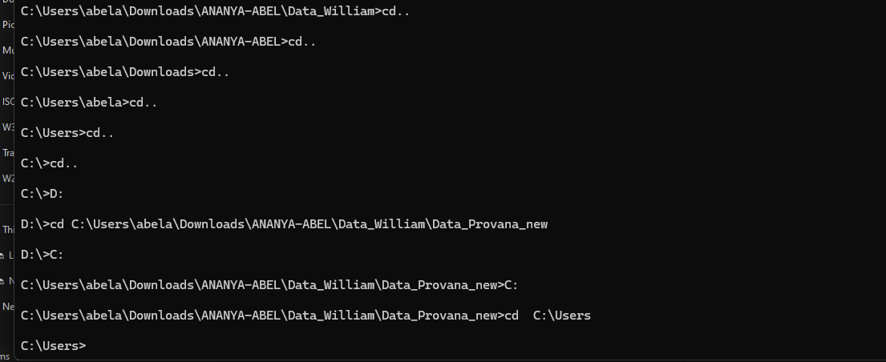

Figure 1.2 Window Firewall & Network Protection

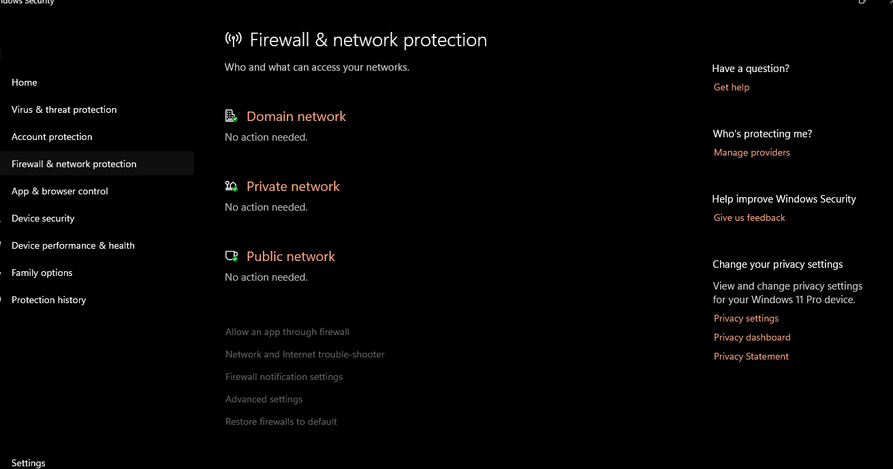

Figure 1.3 Creating new network permissions

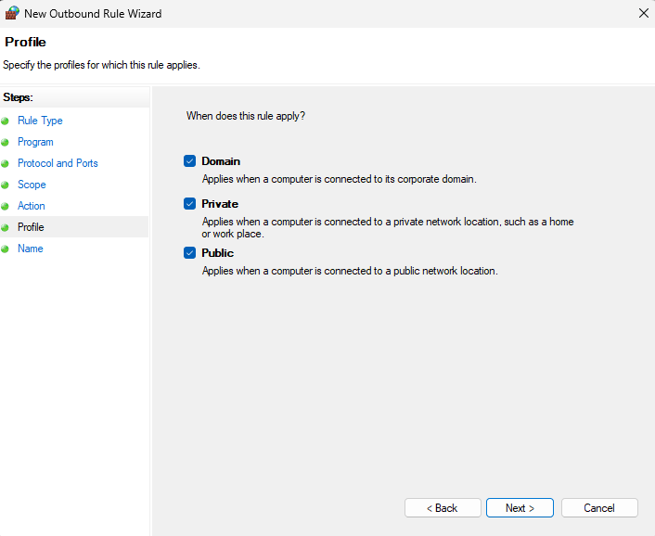

Figure 1.4 Creating new Instance for Cyberdojo

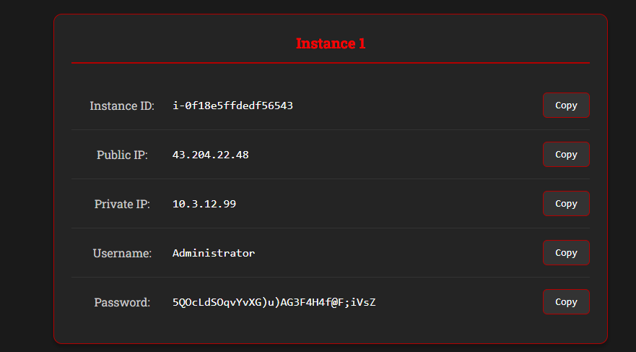

Figure 1.5 Creating new Instance for Cyberdojo

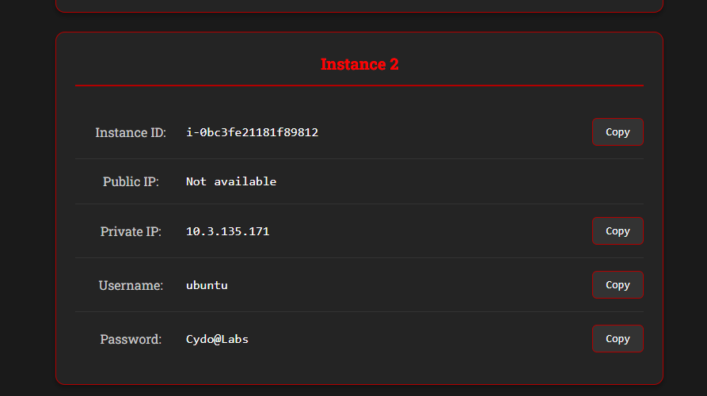

Figure 1.6 Windows Advanced Security

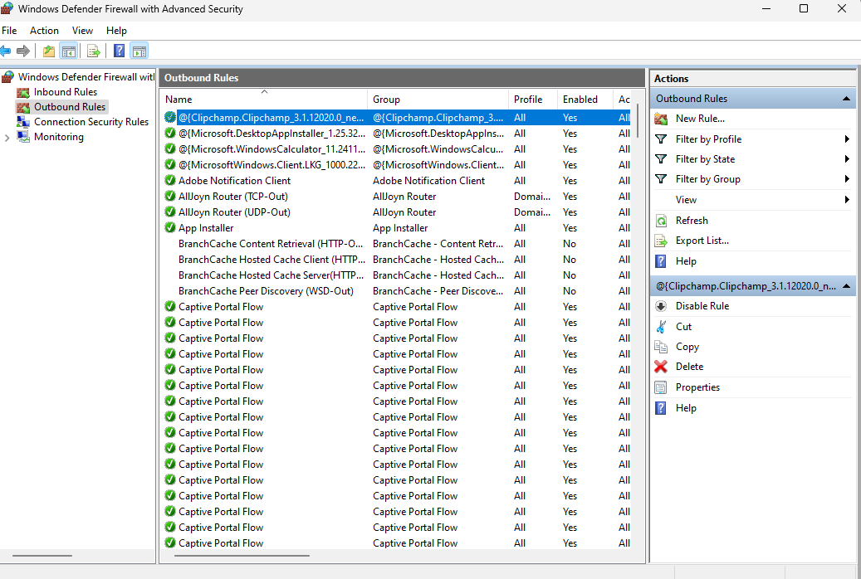

Figure 1.7 Total Computer Management

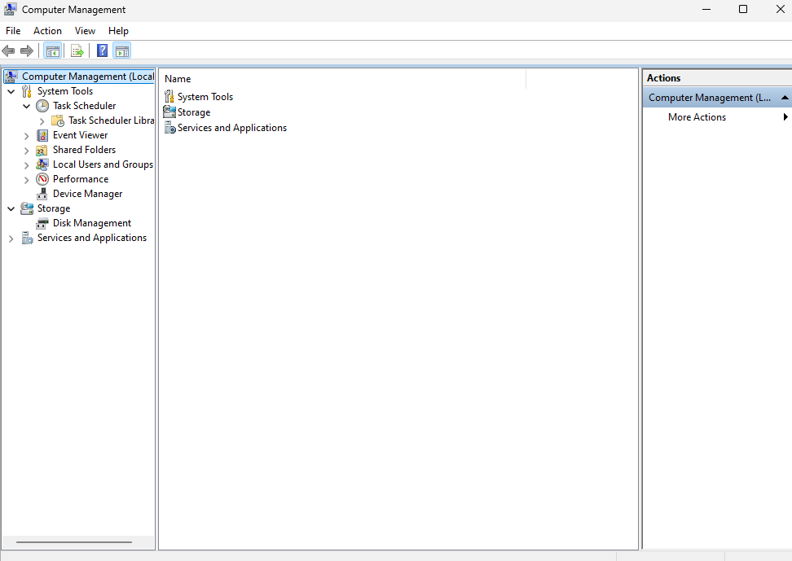

Figure 1.8 Control Panel for Windows Firewall

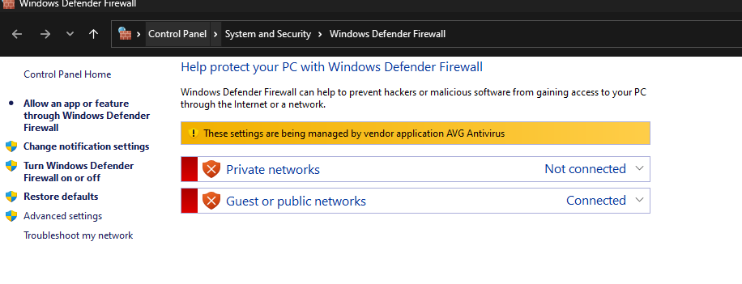

**Figure 1.9 Network analysis using CPT**

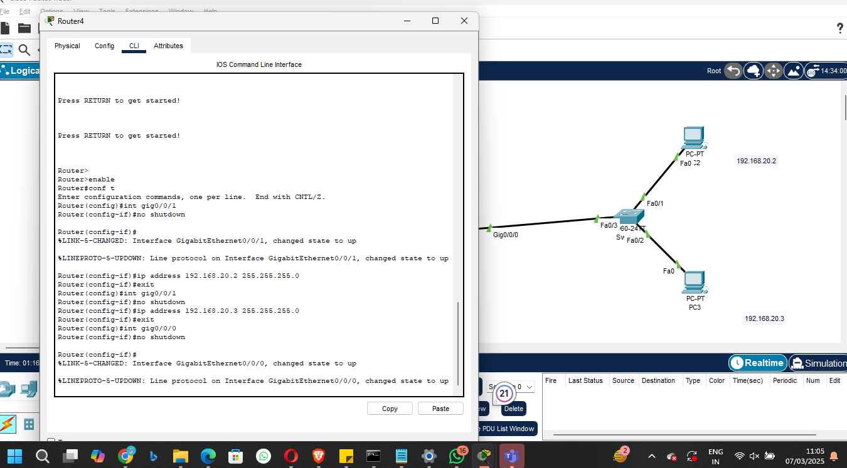

**Figure 2.0 Network analysis using CPT** Router configuration

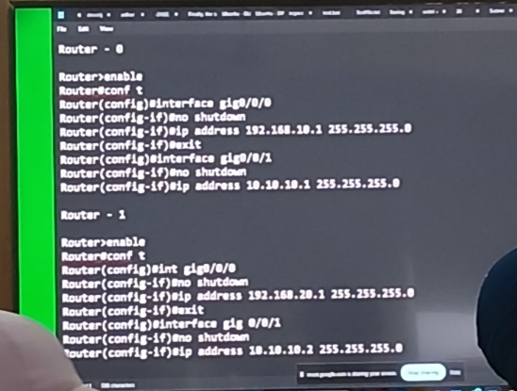

Figure 2.1  **Network analysis using CPT** Switch configuration

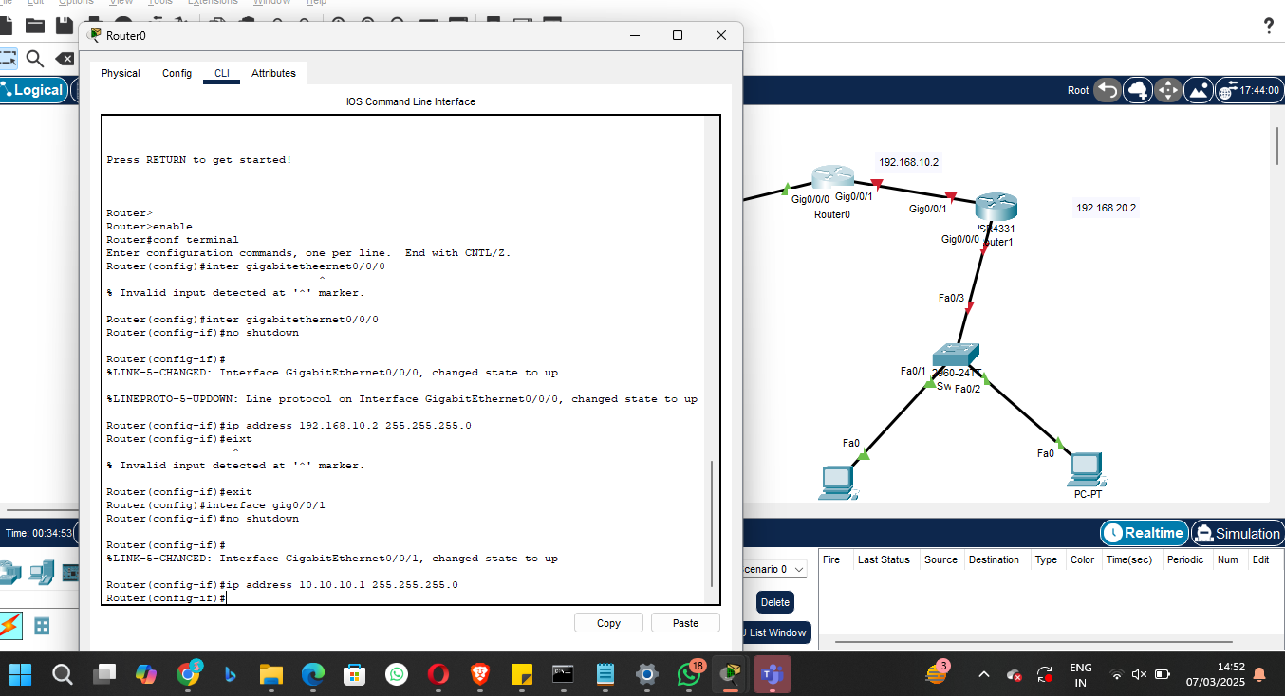  
  
  
  
Figure 2.2 Cyber dojo content on how to Bypass Endpoint Security

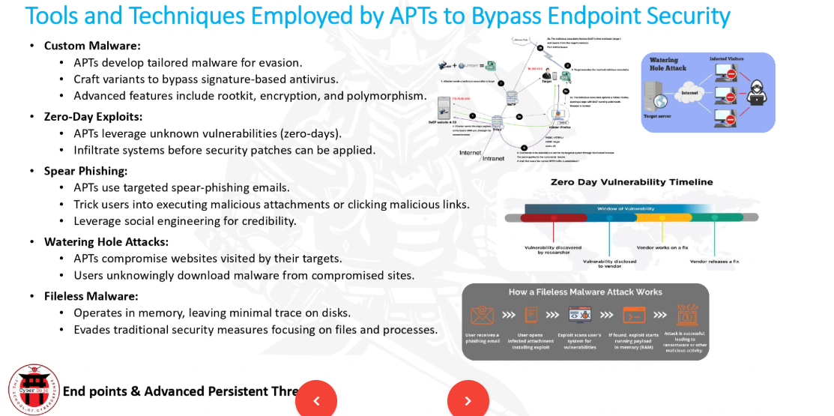

Figure 2.3 Cyber dojo content on how to Bypass Endpoint Security

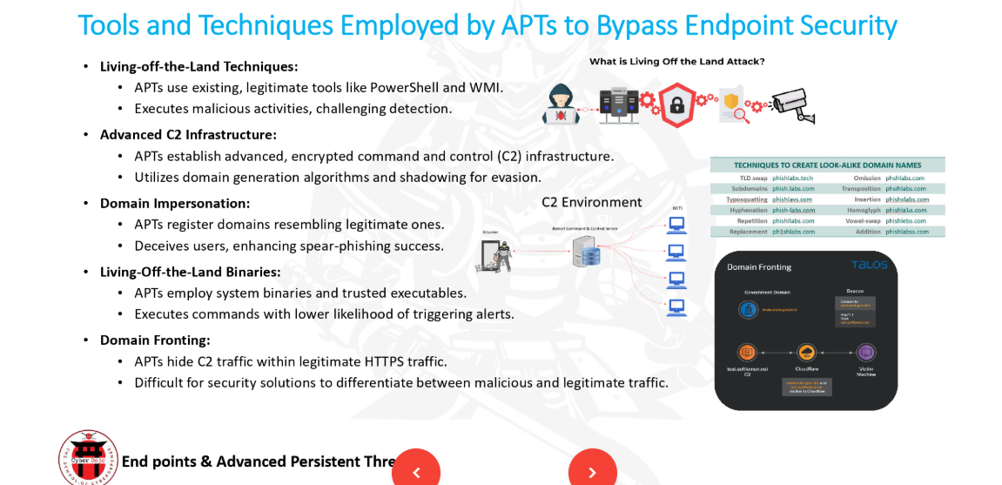

Figure 2.4 Enabling Switch configuration



Figure 2.5 LLMNR attack

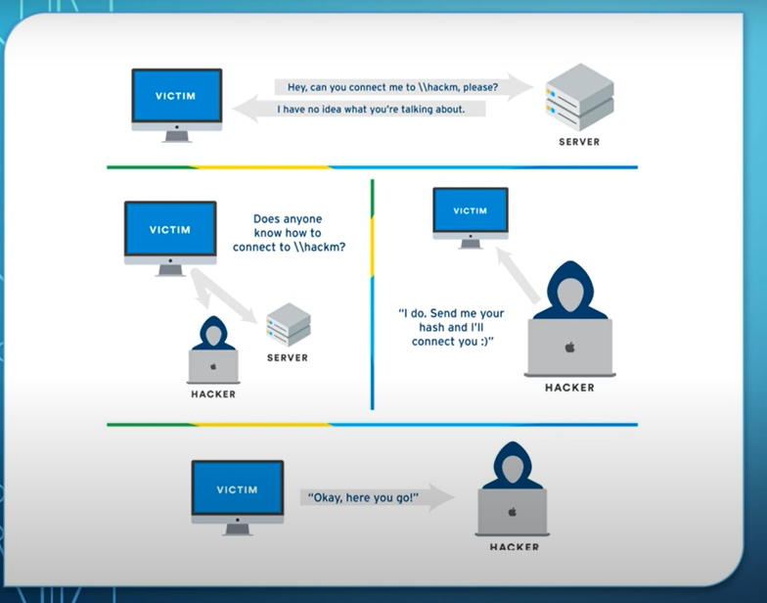

Figure 2.6 Kali Python Responder

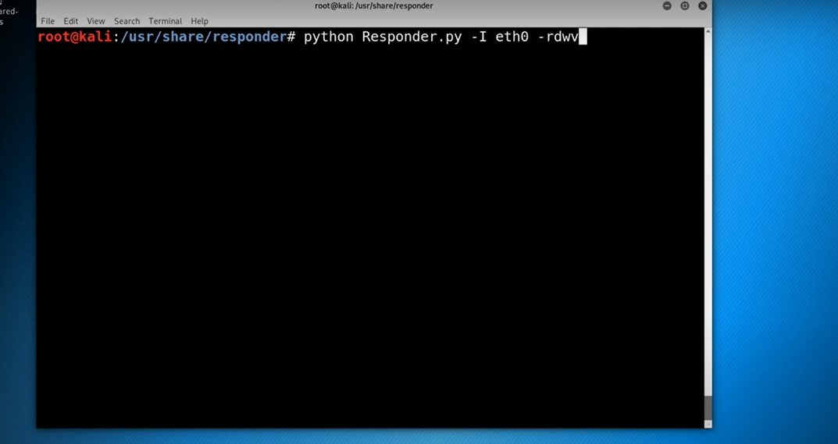

Figure 2.7 Breaking hash

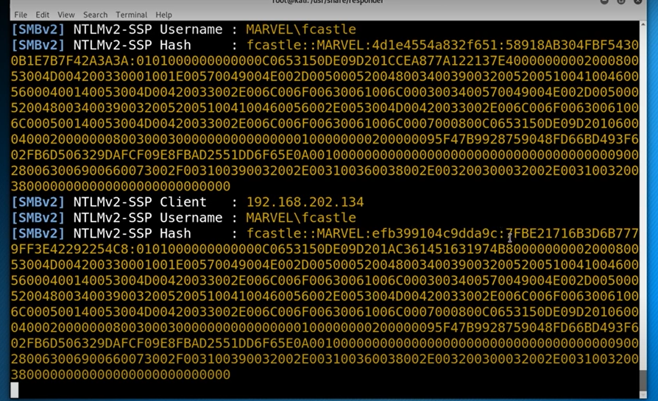

**Figure 2.8 LLMNR/NBT - NS poisoning**

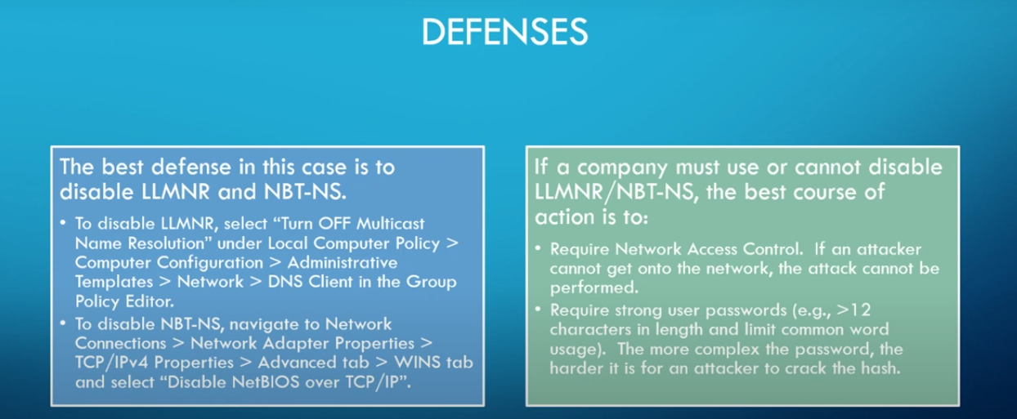

Figure 2.9 Lost Packets

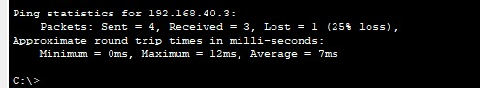  
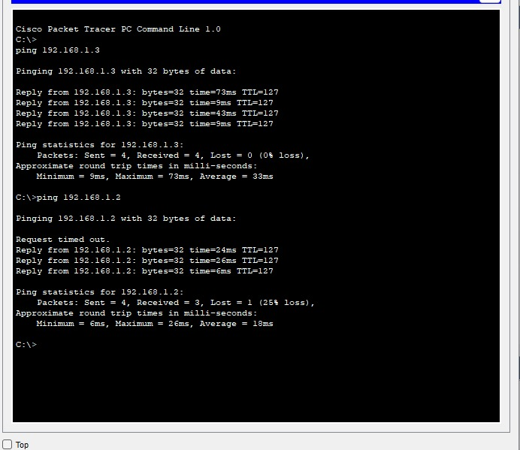  
  
Figure 3.0 SIEM tech and Architecture

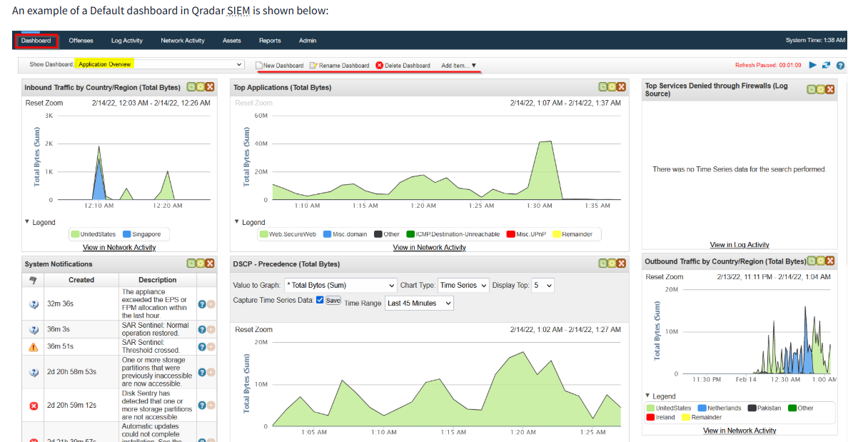

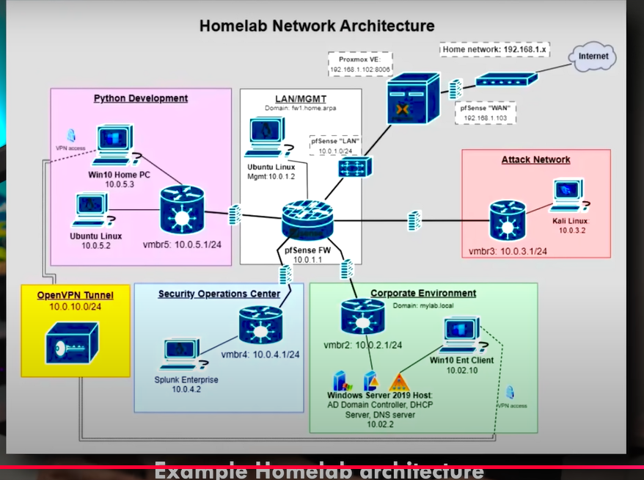

Figure 3.1 Corporate Architecture

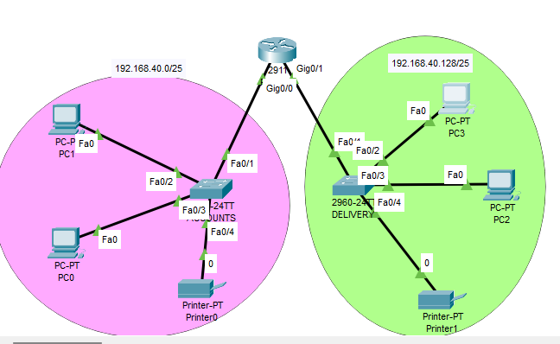  
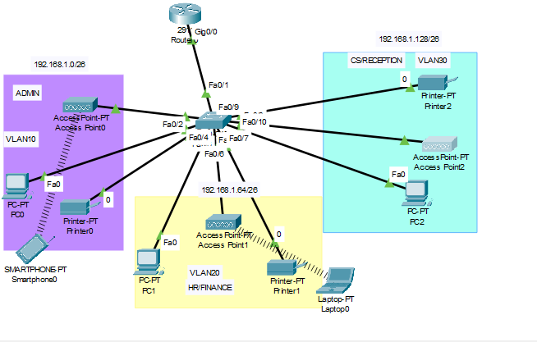

Figure 3.2 Home Architecture

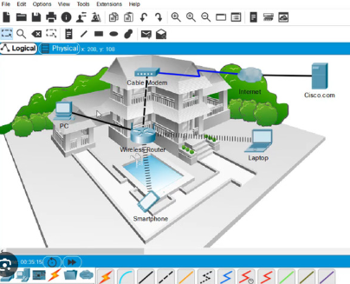

Figure 3.3 IP config

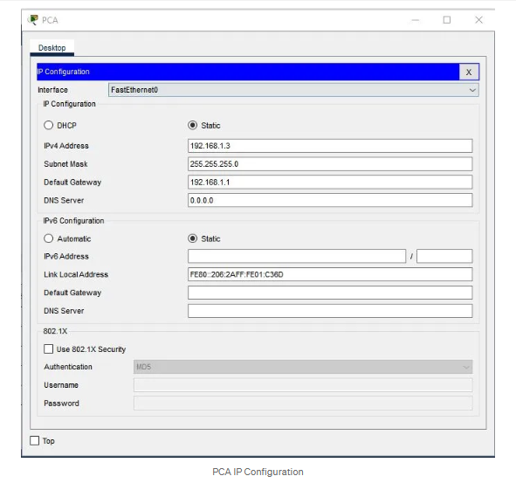

**SUSTAINABLE DEVELOPMENT GOALS**

The proposed cyber security solution is not only robust and adaptive—it’s also designed with sustainability and inclusivity in mind. Built to support organizations of all sizes and across various sectors, it aligns with key **United Nations Sustainable Development Goals (SDGs)** by promoting innovation, reducing inequality in access to secure technologies, and fostering resilient infrastructure.

#### • Scalable Architecture

At the heart of the solution is a cloud-based infrastructure that scales seamlessly. Whether it’s a small startup or a global enterprise, organizations can rely on consistent performance and protection. This scalability supports **Industry, Innovation and Infrastructure**, by providing a resilient digital foundation that grows with the organization.

#### • Customizable Modules

Security isn’t one-size-fits-all. That’s why the system includes modular features that organizations can tailor to their unique needs and resources. This not only makes the solution more cost-effective, but also ensures that smaller teams and organizations with limited budgets aren’t left behind—advancing  **Reduced Inequalities**, by making enterprise-level security accessible to all.

#### • Multi-Platform Compatibility

In today’s diverse digital ecosystem, compatibility is essential. The solution integrates smoothly with both cloud-based and on-premises project management platforms, ensuring organizations can protect their workflows regardless of their tech stack. This flexibility supports **SDG 8: Decent Work and Economic Growth**, by safeguarding digital environments where modern collaboration and productivity take place.

#### • Modular Upgrades

As cyber threats evolve, so should the tools that protect against them. This solution allows for the seamless integration of new modules without disrupting daily operations. This forward-thinking approach supports  **Sustainable Cities and Communities**, by contributing to the development of secure, adaptive digital infrastructure in both urban and remote settings.